Reporting No:4 Week No:4 From :03/06/2024 To :07/06/2024 College ID: 22IT116

Project Title:

**WEEKLY REPORT**

**Work done in last week ( Attach supporting Documents):**

1. 03/06/2024 Monday

* 9.30am to 11.30 am: Introduction about our Project.
* 12.00pm to 2.30 pm: Setup MongoDB, React, Express and node js for our project and solve MongoDB connection error

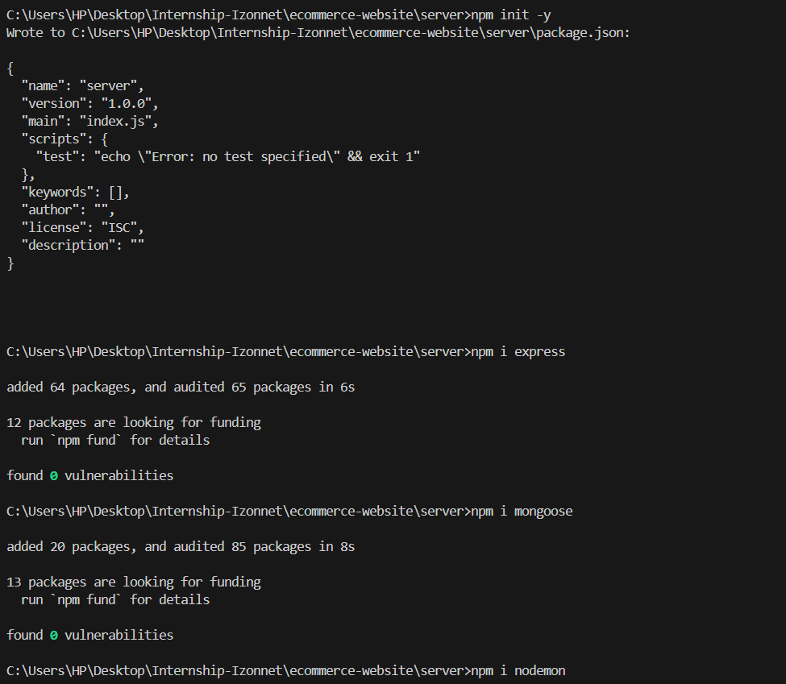

* 3.00 pm to 5.00 pm: Create Navbar add apply CSS

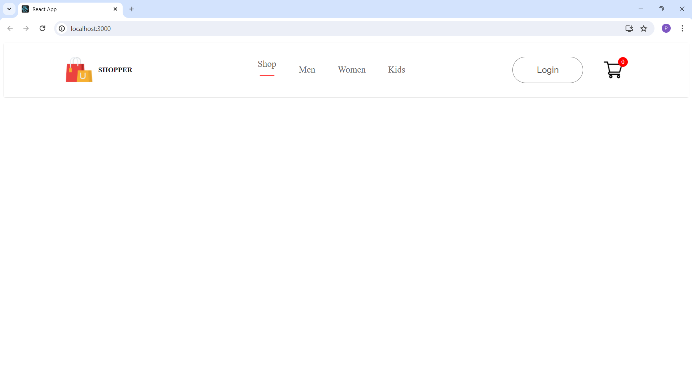

1. 04/06/2024 Tuesday

* 9.30am to 11.30 am: Solve error corresponding to CSS (CSS not apply on the class)
* 12.00pm to 2.30 pm: Create Route for Projects

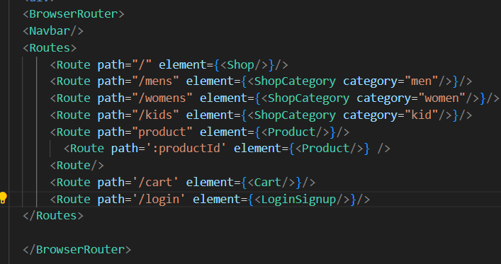

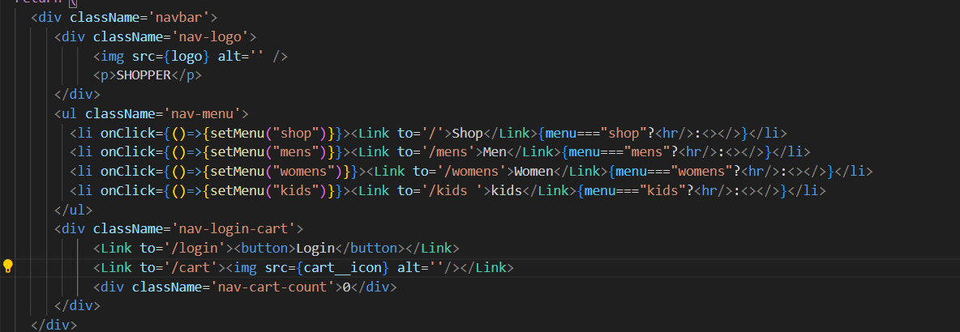

* 3.00 pm to 5.00 pm: I collect all the `picture (or photo) for my ecommerce website.

1. 05/06/2024 Wednesday

* 9.30 am to 11.30 am: Create Shop page

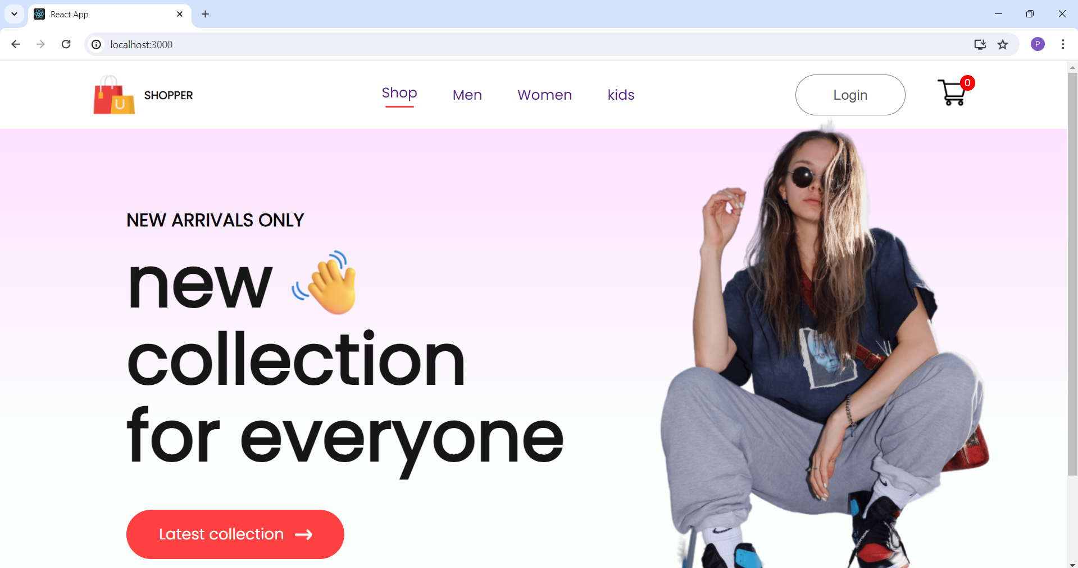

* 12.00pm to 2.30 pm: Add CSS Styling in shop page
* 3.00 pm to 5.00 pm: Creating Popular item for shop in shop page

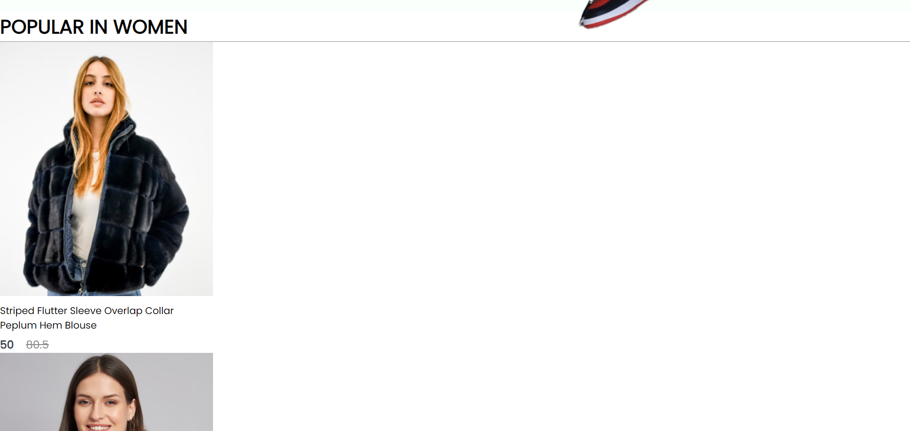

1. 06/06/2024 Thursday

* 9.30 am to 11.30 am: Add CSS styling in Popular Page

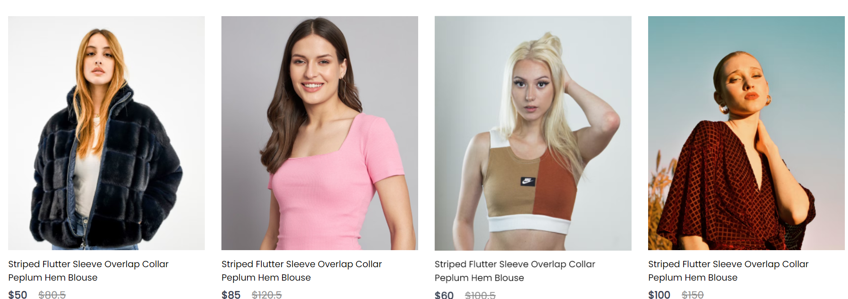

* 12.00pm to 2.30 pm: Create a Exclusive offers for customer

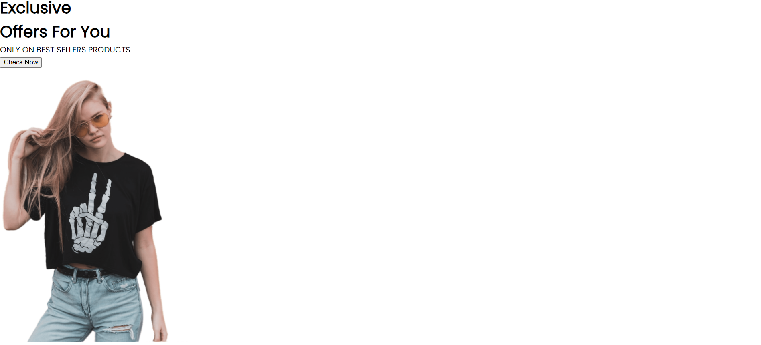

* 3.00pm to 5.00 pm: Add CSS for Exclusive offers for customer

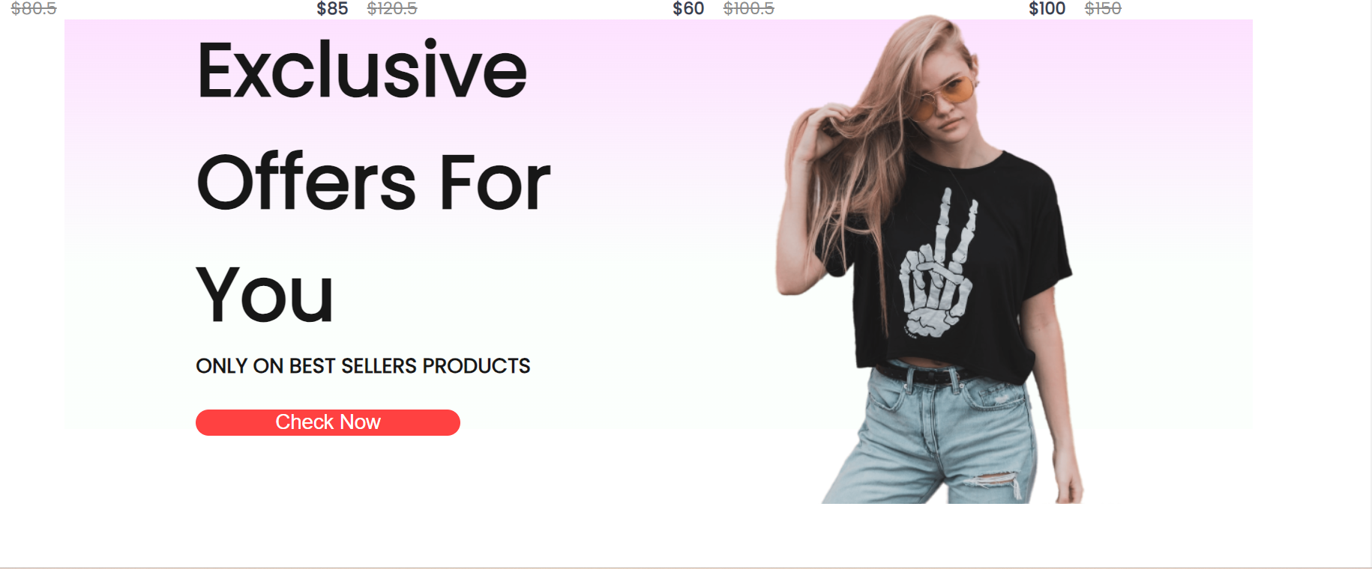

1. 07/06/2024 Friday

* 9.30 am to 11.30 am: Add new Collection Field in my project

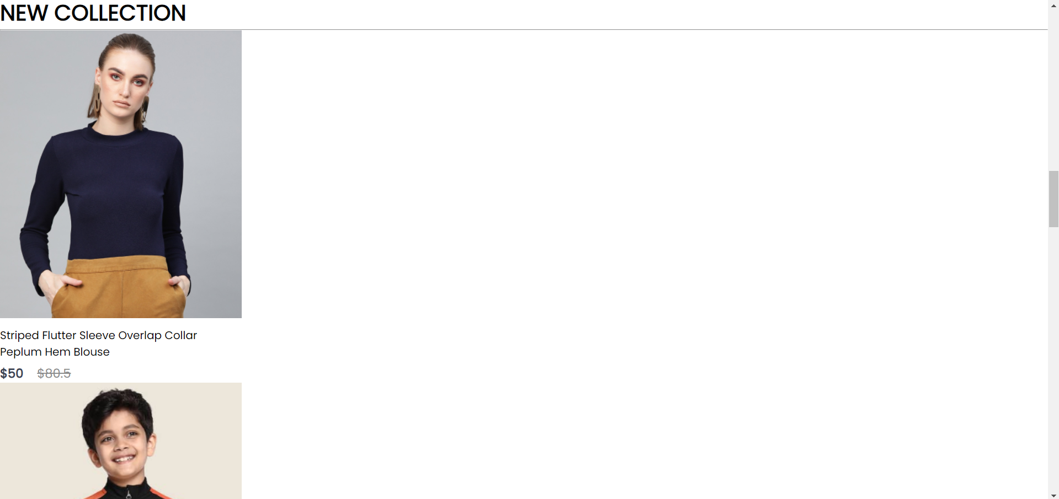

* 12.00pm to 2.30 pm: Apply CSS property to New Collection

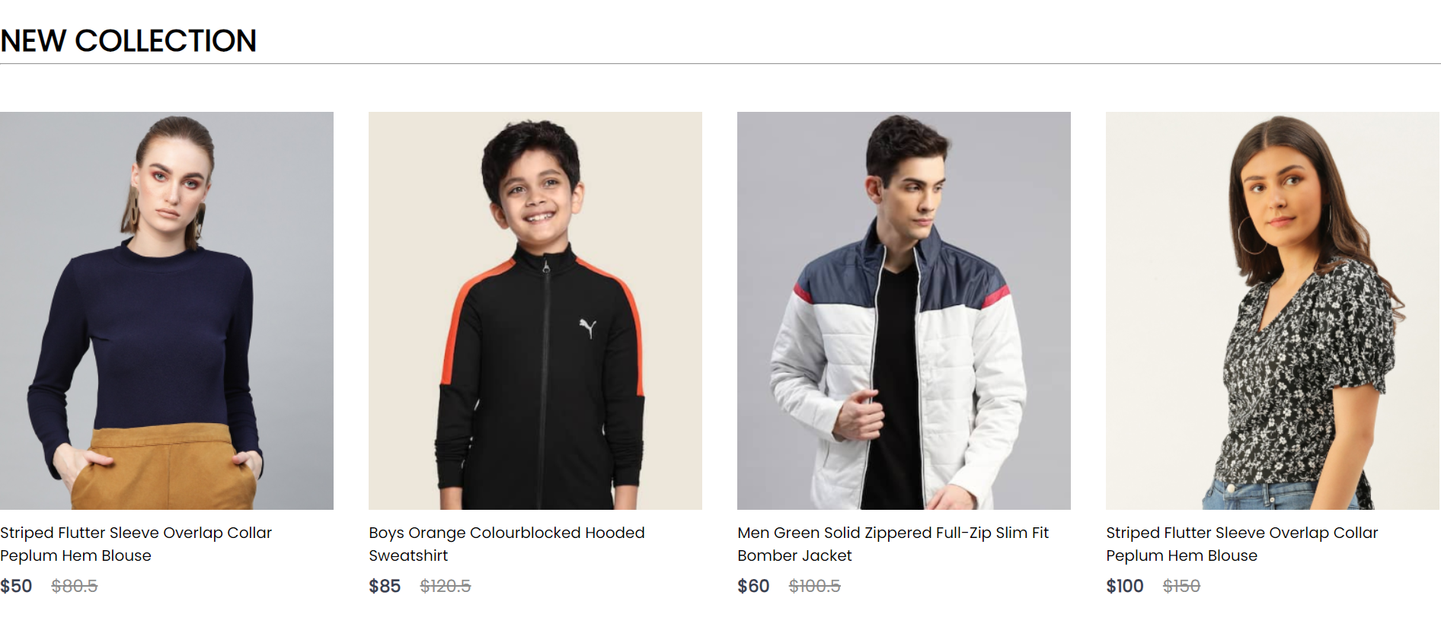

* 3.00pm to 5.00 pm: Create a newsletter component and add CSS for it.

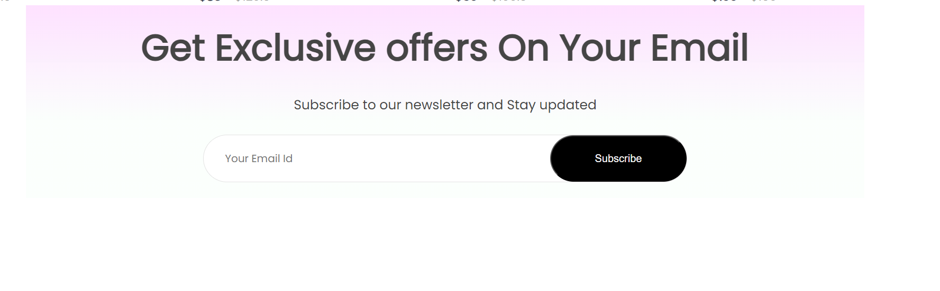

**Plans for next week:**

1. Complete Frontend Part of Project

2.Start backend of the Project.

**References:**

1. YouTube Channel: [Thapa Technical](https://www.youtube.com/@ThapaTechnical)
2. React Documentation
3. Express Documentation
4. Node Documentation
5. MongoDB Documentation

**Signature of External Guide Signature of Internal Guide**

Student Id: 22IT116

Student Name: TRUSHANGKUMAR SUMANBHAI PATEL